Melsonby Parish Village Show
Saturday 17th August 2019

Melsonby Methodist School
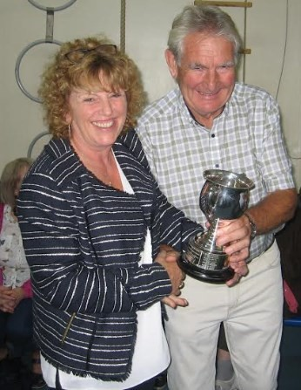

Admission: Adults 30p
Children 15p

Times

Staging of exhibits: 9.30 am – 12.30 pm
Doors open. All welcome: 3.30 pm
Presentation of Trophies: 4.30 pm
Auction of produce / raffle draw: to follow
Entry Fees
Adults: ( 16 years and over): 15p per entry
Juniors: (under 16 years) ; no fee

Prizes
1st place 50p 2nd place 30p 3rd place 20p

Cups and Trophies awarded for most points
H Lamb Challenge Cup Class A Vegetables and Fruit
Runner-up Trophy Class A Vegetables and Fruit
Leek Club Trophy Classes A3 and A4 Pot and Trench Leeks
Rose Bowl Class B Flowers
Runner-up Shield Class B Flowers
Jan Archer Trophy Class C Floral Art
Kim Nixon Trophy Class D Preserves and Baking (Adults)
Runner-up Shield Class D Preserves and Baking (Adults)
West Trophy Class D+ Junior’s Baking
Beehive Trophy Class E Artwork and Crafts (Adults)
Geoff Garrett Trophy Class E+ Junior’s Artwork and Crafts
Stokoe Trophy Class F Photography
Stokoe Trophy Class F+, Junior’s Photography
Wendy Vart Memorial Shield Best Newcomer in Show

Cups and Trophies awarded for best exhibit in Classes
Larry Thompson Trophy Best Exhibit in Class A
Golding Cup Best Exhibit in Class B

SHOW RULES

Entry forms must be returned to Lynda Watts, 16 East Road, Melsonby by 9pm Thursday 15th August. Entries will not be accepted thereafter.
No entries shall be allowed in both the Junior and Senior sections. Adults are classed from age of 16. Anyone younger must enter the Junior classes.
Exhibitors are allowed one entry for each individual class number.
Exhibits for Classes A and Classes B must be grown by the exhibitor within the Parish of Melsonby. The fact of an exhibitor entering The Show gives The Show Committee full power to inspect the exhibitor’s garden/allotment. Disqualification and forfeiture of all fees and prize money will ensue if exhibits are found not to have been grown in the village.
Exhibits may be staged between 10am and 1pm on the day of the show. Judging will commence at 1:00pm. No exhibit can be removed before presentation of trophies.
Each exhibit must bear a number obtained from a member of The Show Committee on arrival of the exhibiting hall. Exhibitors will be responsible for the placing of their cards and the correctness of the detail thereon.
Each exhibitor is asked to provide the necessary plate/ vase/container for exhibits. (Please mark these for safe return). The Show Committee will take all reasonable care of exhibits but will not be responsible for loss or damage.
For the purpose of this show the rules regarding organic mean that the soil and plants are not treated with synthetic commercial fertilizers, pesticides or fungicides during the current growing season.
The Judges’ decisions are final.
Protests: Any protest must be delivered in writing to The Show Committee within 1 hour of The Show being open to the public and must be accompanied by a deposit of £1 which will be refunded if the protest is upheld.
Any matter connected with The Show or not covered by the rules will be dealt with at the discretion of The Show Committee
It is hoped that the exhibitors will allow their exhibits to be sold at auction for the benefit of The Allotment Association and future Shows Prize money will be paid in the days following The Show.

Show Judges  Vegetables and Fruit: Bernie Atkinson  Flowers: Bernie Atkinson  Floral Art: Sheena Simpson  Preserves and Baking: Jean Brown  Artwork and Crafts: John Ridley  Photography: Maurice Weeks | Show Committee Members  Brian Bottle  Judy Bottle  Dorothy Cole  Vince Elrington  Will Smith  Lynda Watts

Class A
Vegetables and Fruit
A1) 5 Potatoes, round A20) 2 Turnips. Yellow or white
A2) 5 Potatoes, kidney A21) 2 Swedes
A3) 2 Leek, pot. Not more than 6” to the button. A22) 2 Celery, any variety
A4) 2 Leeks, trench. To be 9” or over to the button. A23) 2 Lettuce, cabbage
A5) 3 Onions from set. Dressed. A24) 5 Tomatoes
A6) 3 Onions from seed. Dressed A25) 1 Cucumber
A7) 6 Shallots, red A26) 1 Marrow, any variety
A8) 6 Shallots, other than red A27) Collection of vegetables, 2 each
of 4 distinct varieties from
classes A1 - A26 above
A9) 2 Parsnips A28) Collection of salad vegetables /
A10) 2 Carrots, long salad, no less than 4 distinct varieties
A11) 2 Carrots, stump rooted A29) 1 Vegetable and 1 Flower. Varieties –
exhibitor’s choice.
A12) 2 Beetroot, globe A30) Fruit. A plate of 1 variety OR a
A13) 6 Pod Peas collection of mixed varieties.
A14) 6 Broad Beans A31) Collection of organically grown
A15) 6 French Beans produce (see Show Rules for definition of
Organic produce)
A16) 6 Runner Beans A32) Ugly vegetable
A17) 1 Cauliflower
A18) 1 Cabbage, pointed. Dressed.
A19) 1 Cabbage, round. Dressed.
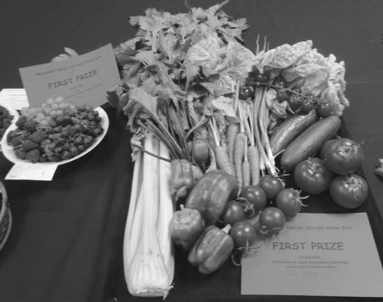

Class B
Flowers *

B1) 3 Dahlias, any variety
B2) 3 Chrysanthemum, any variety
B3) 3 Gladioli
B4) Asters, any number
B5) Sweet Peas. Any number of spikes.
B6) Roses. Any variety. Any container.
B7) Any flowering house plant in a pot
B8) Collection of Mixed Flowers, no less than 4 varieties. Any container. clouds)
* All flowers must be grown in Melsonby
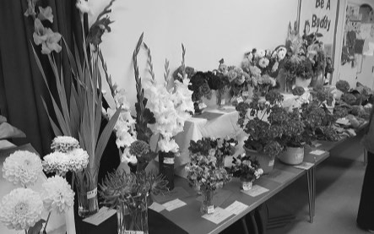

Adult Classes C Floral Art **
C1) Floral Arrangement. Design – Table decoration on a sporting theme
C2) Five Flowers (plus any foliage)
C3) Arrangement in an egg cup
C4) Bowl of floating flowers- Rainbow theme
C5) Buttonhole for a wedding
** Shop bought flowers are permitted

Adult Class D
Preserves and Baking

D1) Chutney/Pickles/Jelly, 1 jar labelled with type
D2) Jam/Marmalade/Curd, 1 jar labelled with type
D3) Sweet Pastry Tart. e.g.: Fruit filled; Bakewell; Treacle
D4) Savoury Quiche
D5) 4 Biscuits or Cookies
D6) 4 Fruit Scones
D7) 4 Cheese Scones
D8) 1 Loaf Cake, any sort. e.g: Dried Fruit; Lemon Drizzle; Banana
D9) 4 Vanilla Cupcakes, decorated in the same design
D10) Traditional Victoria Sponge, max 20cm, filled with jam.
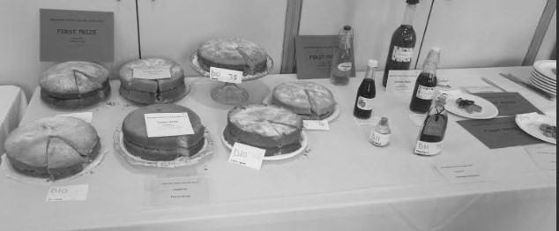
D11) Homemade wine / spirit

Junior Class D+ Baking

Age 8 and under
D+12) 4 Rice kispy/cornflake cakes - decorated
D+13) 4 Jam/Lemon Curd tarts
D+14) 2 Cup cakes, decorated
D+15) 4 Flapjack pieces
Ages 9 – 15
D+16) 4 Rice kispy/cornflake cakes - decorated
D+17) 4 Jam/Lemon Curd tarts
D+18) 2 Cup cakes, decorated
D+19) 4 Flapjacks pieces

Adult Class E

Artwork and Crafts

E1) Painting or drawing. Any medium.
E2) Greetings Card. Any medium. Theme; Tour De Yorkshire
E3) Art or craft item made from a kit. Any medium.
E4) An item for use or display in the home or garden, practical or decorative. Any materials. (Merit given for design and originality - no kits please).
E5) Any item made largely from recycled materials.

Junior Class E+ Artwork and Crafts

Age 8 and under

E+11) Collage made from recycled material – Theme Tour De Yorkshire
E+12) Post card – Tour De Yorkshire
E+13) Information Poster about recycling
E+14) Vehicle made from recycled material
E+15) Write a story/poem in own hand writing with illustrations

Ages 9 – 15

E+17) Collage made from recycled material – Theme Tour De Yorkshire
E+18) Post Card _Tour De Yorkshire
E+19) Information poster about recycling
E+20) Vehicle made from recycled material
E+21) Write a story/poem in own hand writing with illustrations

Adult Photography Class F
F1) Architecture
F2) Clouds
F3) Village Life
F4) Summer
F5) Black and white
Junior Class F+ Photography

Age 8 and under
F+11) Creepy Crawls
F+12) My favourite photo from 2018/2019

Ages 9 - 15

F+13) Creepy Crawls
F+14) My favourite photo from 2018/2019
Guess who?

Quiz

ENTRY FORM
Name:

Address:

E-mail:

Class Number | Description of Exhibit |  | Fee
 |  | Total:

Return to Lynda Watts, 16 East Road Melsonby (Tel 718595) NO LATER THAN 9pm THURSDAY 15 AUGUST 2019
If you have never exhibited in the Show before, HAVE A GO THIS YEAR.
Just one exhibit will make a difference and ensure that the show continues to be an important event in the village’s calendar.
Even if you decide not to enter an exhibit, please come along and support our Village Show. You are promised a fun afternoon. In addition to perusing your friends’ and neighbours’ prize exhibits, there is the opportunity to obtain lots of lovely fresh veggies and home- made produce for your family’s delectation. Always a highlight of the afternoon, and not to be missed, is an auction of produce under the hammer of the irrepressible Mr Vince ‘Who Will Give Me More?’ Elrington.
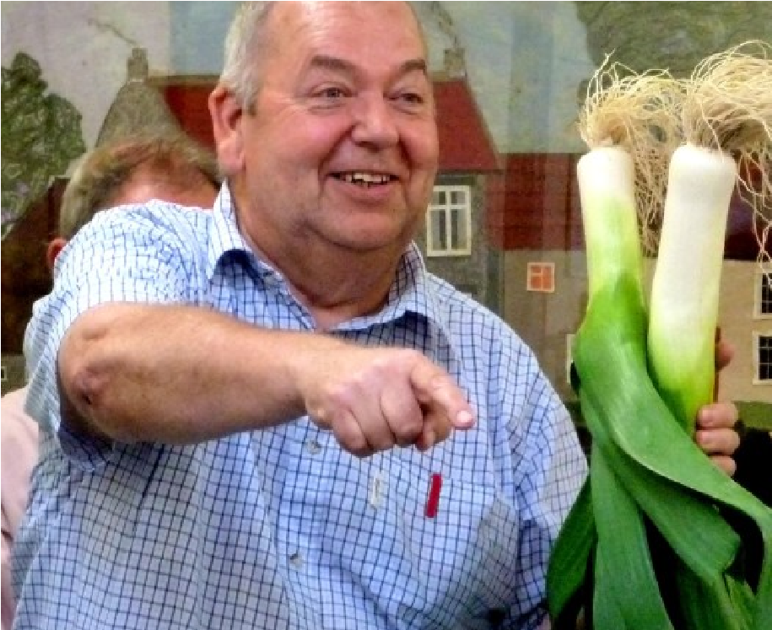

Melsonby Allotment Association
Melsonby Parish Village Show is organised by Melsonby Allotment Association.
Please direct enquires regarding renting an allotment to Brian Bottle (Tel: 01325 718010)

